Shredded Chicken

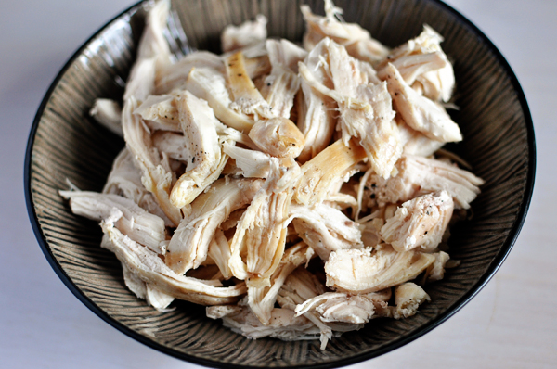

Ingredients

* 1 tablespoon olive oil
* 4 boneless, skinless chicken breasts
* Salt and pepper
* ¾ cup water or low-sodium chicken broth

Directions

1. In a large 12-inch nonstick skillet with a lid, heat the olive oil over medium heat until hot and rippling.
2. Pat the chicken dry and season with salt and pepper on both sides.
3. Place the chicken top-side down in the hot skillet and let the chicken cook for 5 minutes until golden brown on top.
4. Flip the chicken, add the water or chicken broth, cover the skillet and let the chicken simmer gently over medium heat for 7-10 minutes until the chicken is cooked through (it will register 160 degrees on a thermometer). Don't overcook or it might be dry. While the chicken is simmering, add additional water 1/4 cup at a time if the liquid evaporates too quickly.
5. Remove the chicken from the skillet. Let it cool slightly before shredding.

***The cooked chicken will keep well-covered in the refrigerator for up to 3 days or can be frozen for up to 2 months.***